Basic interferometry in radio astronomy
- Introduction
  - Overview of Radio Interferometry
In radio astronomy, an interferometer combines signals from multiple antennas to measure the spatial coherence of incoming radio waves. For solar radio bursts, this technique allows high-resolution imaging and precise tracking of rapid intensity changes over time and frequency.
Two key measured quantities are:
- Visibility Amplitude – Represents the correlated signal strength between antennas. It indicates how much of the solar burst’s emission comes from a given spatial scale, helping determine source size and structure.
- Visibility Phase – Encodes positional information of the source. Accurate phase measurements are essential for reconstructing the burst’s true location and shape on the Sun’s disk.
- Together, amplitude and phase form the complex visibility, which is transformed via Fourier inversion to produce detailed solar radio burst images.

  - Basic Theory of Interferometry
    - The Concept of Baselines
The baseline is the vector distance between two antennas. Longer baselines sample higher spatial frequencies in the sky’s Fourier plane, which narrows the synthesized beam and increases angular resolution. In short: longer baseline → finer detail in the image.
$$θ_{res}≈\frac{λ}{b}$$
    - Time Delay
Because of the different path lengths, the signal received by the second antenna is delayed by a geometric delay $τ_{g}$ relative to the first antenna.
$$τ_{g}= \frac{bs}{c}$$

Where,
- b: The baseline (m)
- s: distance to source (km)
- c: speed of light (m/s)

    - The Visibility meaning
- Visibility is the fundamental measurement in a radio interferometer, representing the spatial coherence of the incoming radio wave between a pair of antennas.
- Mathematically, it is the complex cross-correlation of the electric fields received at two antennas, as a function of baseline vector and observing frequency.
- Visibility is NOT a function of the absolute position of the antennas (provided the emission is time-invariant, and is located in the far field).
- The Visibility is Hermitian: V(u,v) = V*(-u,-v). This is a consequence of the intensity being a real quantity.
- Each observation of the source with a given baseline length provides one measure of the visibility.
- Unit of Visibility:
+ If the signals are calibrated in flux density, visibility is measured in Janskys (Jy), where:
$$1J_{y}={10}^{-26}Wm^{-2}H_{z}^{-1}$$
+ If not yet calibrated, the raw visibility is in correlator units (dimensionless), proportional to the product of voltages at the antennas.
    - The u-v Plane Sampling
Let us imagine the measurements of V(b) to be taken entirely on a plane. Then a considerable simplification occurs if we arrange the coordinate system so one axis is normal to this plane.
Let (u,v,w) be the coordinate axes, with w normal to the plane. All distances are measured in wavelengths. Then, the components of the unit direction vector, s, are:
$$s=\left(l,m,n\right)=\left(l,m,\sqrt{1-l^{2}-m^{2}}\right)$$
And,
$$ⅆΩ=\frac{ⅆlⅆm}{\sqrt{1-l^{2}-m^{2}}}$$

    - The source brightness on the sky (I_{v}(s))
The average signal is independent of the time t, but is dependent on $τ_{g}$ and hence on the distribution of the brightness.
For a solar radio burst, I(s) spikes dramatically in regions where the burst occurs on the Sun’s surface or corona.
- So the term V₁V₂ is proportional to source intensity, I_{v} ( measured in Janskys (Jy) ).
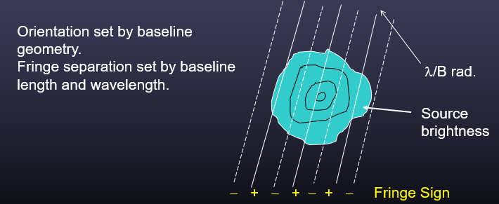
- The correlator multiplies the true sky brightness distribution by this fringe pattern and integrates the result over the entire sky. The alternating positive (+) and negative (−) fringes represent regions where signals from the two antennas add or cancel, and the resulting integrated value forms the complex visibility for that baseline.

  - Signal Processing in Interferometers
    - The Stationary, monochromatic interferometry
The diagram illustrates the basic principle of a two-element radio interferometer.

average
multiply
$$V=V_{1}\cos\left[ω\left(t-τ_{g}\right)\right]$$
$$V=V_{2}\cos\left[ωt\right]$$
$$V_{1} V_{2}\left[cos\left(ωτ_{g}\right)\right]/2= V_{1} V_{2}\left[cos\left(2πf\frac{bs}{c}\right)\right]/2$$
b
s
s
$V_{1}$ $V_{2}\left[cos\left(2ωt-τ_{g}\right)+cos\left(ωτ_{g}\right)\right]/2$

$$V=Rc$$
The response from an extended source is obtained by integrating the response over the solid angle of the sky:
$$V=Rc= V_{1} V_{2}\left[cos\left(2πf\frac{bs}{c}\right)\right]/2= ∬I_{e}\left(s\right)\left[cos\left(2πf\frac{bs}{c}\right)\right]ⅆΩ$$
Key point: the vector (s) is a function of direction, so the phase in the cosine is dependent on the angle of arrival.
    - The complex picture of interferometry
In order to increase the resolution of solar radio burst image and the cosine correlator only recover the even part of the signal, we need to generate the sine pattern by increasing a 90 degree phase shift in one of signal part, which relates to the concept of lwa antenna. The diagram shows how we generate the sine pattern.
average
multiply
$$V=V_{1}\cos\left[ω\left(t-τ_{g}\right)\right]$$
$$V=V_{2}\cos\left[ωt\right]$$
$$V_{1} V_{2}\left[sin\left(ωτ_{g}\right)\right]/2= V_{1} V_{2}\left[sin\left(2πf\frac{bs}{c}\right)\right]/2$$
b
s
s
$V_{1}$ $V_{2}\left[sin\left(2ωt-τ_{g}\right)+sin\left(ωτ_{g}\right)\right]/2$

90*

$$V=Rs$$
Attention, mathematically, this is still correlation — it’s just correlation with a quadrature reference signal, giving the imaginary part of the result. Especially, it not making the interferometer.
The odd part of signal is:
$$V=Rs= V_{1} V_{2}\left[sin\left(2πf\frac{bs}{c}\right)\right]/2= ∬I_{o}\left(s\right)\left[sin\left(2πf\frac{bs}{c}\right)\right]ⅆΩ$$
Combine with the even part, we can now define a complex and final function of Visibility:
$$V=R_{C}-ⅈR_{s}=Aⅇ^{-ⅈϕ}$$
Where,
The visibility amplitude:
$$A=\sqrt{R_{C}^{2}+R_{s}^{2}}$$

The visibility phase:
$ϕ=\tan^{-1}\left(\frac{R_{s}}{Rc}\right)$ = -2πf (b⋅s/c)
    - The 2-d Fourier Transform Relation
The arrangement of antennas in an interferometer determines how the array samples the uv-plane, and thus how well an image can be reconstructed.
Certain special geometries simplify the relationship between baselines and sky projection, making calibration and imaging easier.
From the function of Visibility above, we have:
$$V(b)=R_{C}-iR_{S}={{∬I}_{ν}(s)}e^{-2πifb⋅s/c}dΩ$$

Then$fb⋅s/c$= ul + vm + wn $≈$ ul + vm, from which we find:
$$V_{ν}(u,v)={\frac{I_{υ}(l,m)}{\sqrt{1-l^{2}-m^{2}}}e^{-2iπ(ul+vm)}}dldm$$
Where,
- (u,v) are the projected baseline coordinates, measured in wavelengths, on a plane oriented facing the phase center.
- (l,m) are the sines of the angles between the phase center and the emission, in the EW and NS directions, respectively.

- Science Application
  - Early concept and requirement
In order to move from theory to practice, it is essential to demonstrate how radio interferometry can be applied to real observations of solar radio bursts. A simple approach is to construct an interferometer using just two LWA (Long Wavelength Array) antennas.
With two antennas separated by a known baseline, we can measure correlated signals (visibilities) that carry both amplitude and phase information about the incoming solar emission.
Simulation problem satisfying the following requirements:
- Two Long Wavelength Array antennas ( each provides X=cos and Y=sin baseband streams ).
- Frequency: 35 MHz
- Baseline: 400 m
- Wavelength λ = c/f ≈ 8.57 m
- Max geometric delay: $τ_{g}$max ≈ B/c ≈ 1.33 μs ( when s >> b)
- 2-element resolution: θ ≈ λ/B ≈ 0.0214 rad ≈ 1.23 degree.
The diagram shows how we correlate the signal by pair:

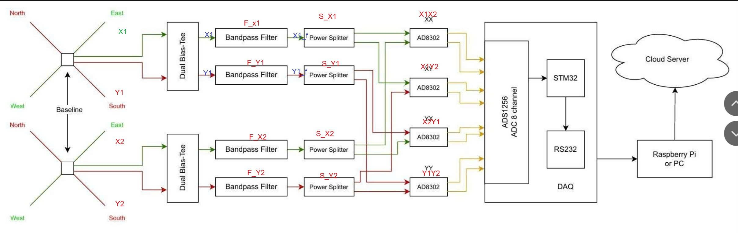
From the two X/Y pairs which forming four time-averaged products:
Cxx=⟨X1X2⟩, Cxy=⟨X1Y2⟩
Cyx=⟨X2Y1⟩, Cyy=⟨Y1Y2⟩
Combine them into the single complex visibility V for this baseline:
V=⟨V1​(t)V2∗​(t)⟩
≈ V = (X1 + jY1)(X2 - jY2) = (Cxx + Cyy) + j(Cyx-Cxy)
Then, is easy that:
∣V∣ = $\sqrt{{\left(C_{xx}+C_{yy}\right)}^{2}+{\left(C_{yx}-C_{xy}\right)}^{2}}$
$$ϕ=\tan^{-1}\left(\frac{C_{yx}-C_{xy}}{C_{xx}+C_{yy}}\right)$$
- These two component is exactly what imagers ( CASA/WSClean apps ) need to generate the image of solar radio burst ( only the 1D image ).

  - Adding u-v plane ( generated track plot by chatgpt ) ( Extension GPSDO application )
More component into the project:
- Source declination: δ= +15 degree ( angle of a celestial object north (+) or south (–) of the celestial equator )
Ex: from +90° (north celestial pole) to –90° (south celestial pole).

- Hour angle: −4 h → +4 h ( Earth rotates 15° per hour, so 1h HA = 1h of real time )
We have the coordinate of each elements (u,v,w) in wavelength:
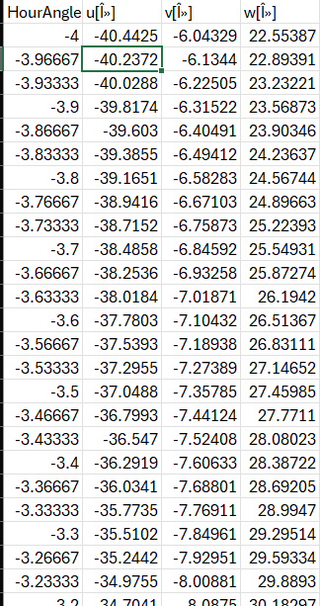
This plot is a u–v track of the interferometer:
( The w coordinate is ignored because the Sun’s angular size is small, so the flat-sky approximation holds ).

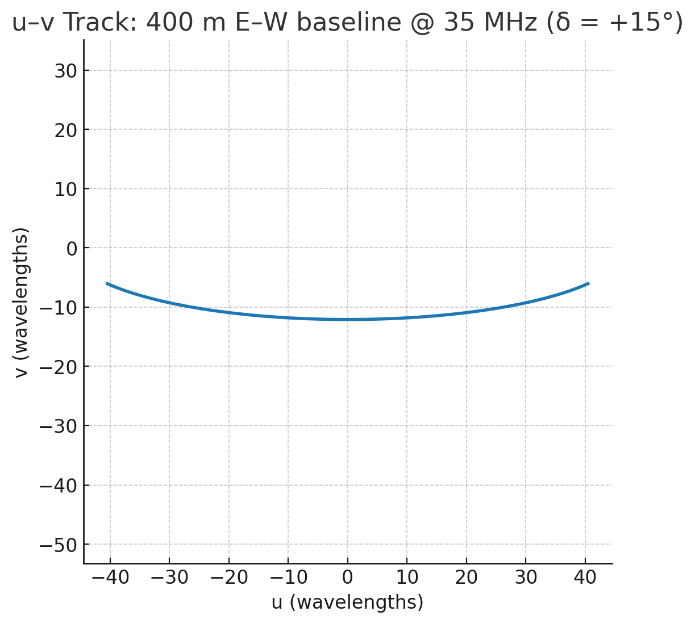
- Conclusion:
- (u, v) represent one point in the Fourier plane of the sky brightness distribution.
- The longest distance on the u-axis (≈ ±40 λ) gives the best angular resolution in the East–West direction.
- The small range in v (≈ -15 λ) shows limited resolution in the North–South direction.
- The current setup is suitable for measuring 1D structure of solar bursts and their spectral/time variability, but not full solar imaging.

